**Air Quality Monitoring**

**Design :**

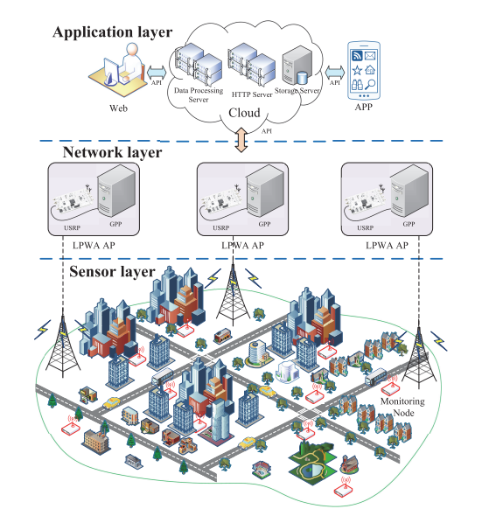

**Algorithm:**

Incorporating predictive modeling to forecast air quality trends based on historical data can significantly enhance the value and functionality of your air quality monitoring project. Here's how you can integrate predictive modeling into the project design algorithm:

**1. Data Collection and Preparation:**

Gather historical air quality data, including parameters like PM2.5, PM10, NO2, SO2, CO, O3, temperature, humidity, and meteorological data (e.g., wind speed, direction).

**2. Data Preprocessing:**

Clean and preprocess the data, handling missing values, outliers, and inconsistencies. Normalize or scale the data as necessary.

**3. Feature Engineering:**

Create relevant features or variables that can aid in prediction. For example, you can derive features like daily averages, moving averages, or lagged values.

**4. Model Selection:**

Choose appropriate predictive models for air quality forecasting. Common models include time series models (e.g., ARIMA, SARIMA), machine learning models (e.g., Random Forest, Gradient Boosting, LSTM, or CNN for deep learning), and hybrid models that combine multiple approaches.

**5. Model Training:**

Split the historical data into training and validation sets. Train the selected models on the training data and tune hyperparameters to optimize model performance. Cross-validation can help assess model robustness.

**6. Validation and Evaluation:**

Evaluate the models on the validation set using appropriate performance metrics such as Mean Absolute Error (MAE), Mean Squared Error (MSE), or Root Mean Squared Error (RMSE). Choose the model with the best performance.

**7. Real-Time Data Integration:**

Implement a mechanism to continuously collect real-time air quality data from your monitoring stations and integrate it into the predictive model. This can be done using APIs, data streams, or periodic batch updates.

**8. Forecast Generation:**

Develop scripts or processes that generate air quality forecasts based on the real-time data and the trained predictive model. Consider generating forecasts for various time horizons (e.g., hourly, daily, weekly).

**9. Visualization and Alerts:**

Create visualizations that display both historical air quality data and the generated forecasts. Implement alerts that trigger when air quality is predicted to exceed predefined thresholds.

**10. Model Updating:**

Implement a mechanism to periodically update the predictive model using fresh historical data. This ensures that the model remains accurate and adaptive to changing air quality patterns.

**11. Communication and Dissemination:**

Make the air quality forecasts and historical data accessible to the public through a user-friendly interface, such as a website or mobile app. Provide explanations and interpretations to help users understand the forecasts.

**12. Documentation and Reporting:**

Maintain documentation on the predictive modeling process, including model selection, training, and performance evaluation. Provide regular reports on the accuracy and reliability of the forecasts.

**13. Continuous Improvement:**

Continuously monitor the performance of the predictive models and update them as needed to incorporate new data or improve accuracy.

